Nutrition Assistant

Project Title
Nutrition Assistant – AI-Based Personalized Nutrition Recommendation System

Abstract
Nutrition Assistant is a full-stack web application that allows users to register, log in, manage their profile, and receive personalized nutrition suggestions and diet plans based on user information.

Problem Statement
Many people struggle to maintain healthy eating habits. This application provides personalized nutrition guidance through a simple interface.

Features
• User Registration & Login
• Personalized Dashboard
• Create Diet Plans
• Nutrition Suggestions
• Profile Management

Tech Stack
Frontend: React, HTML, CSS, JavaScript
Backend: Node.js, Express.js
Database: MongoDB
Tools: VS Code, Git, GitHub

Installation Steps
1. Clone repository
2. npm install
3. npm run dev
4. Open localhost:5173

Usage Instructions
Register, log in, create diet plans, view nutrition suggestions, and update profile.

Screenshots
Login
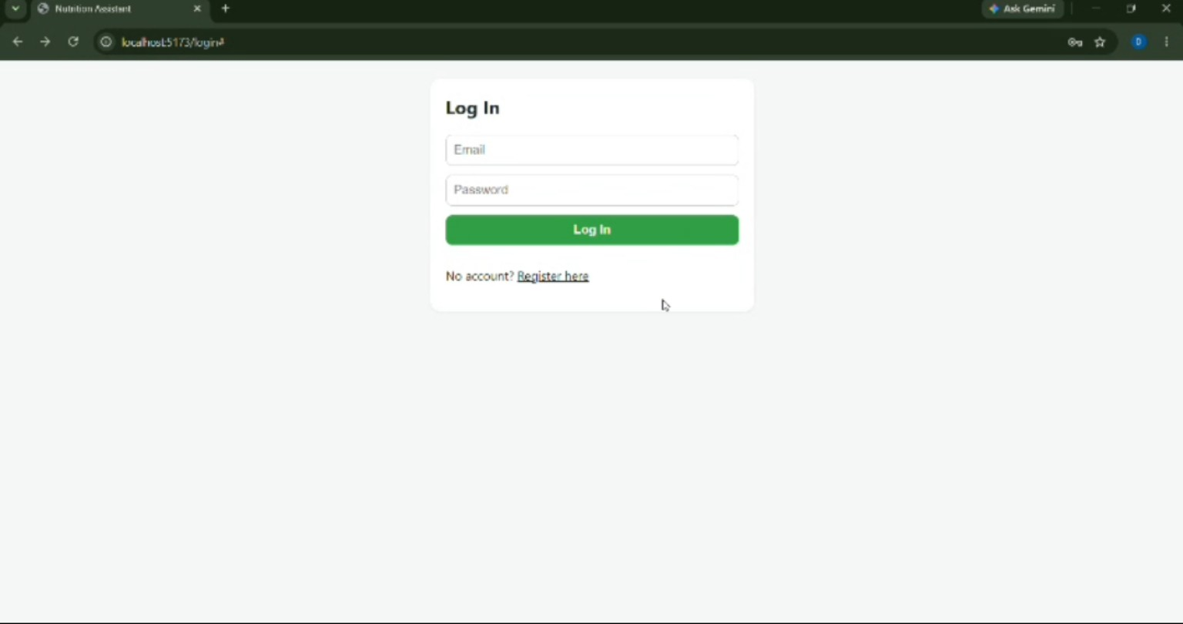
Registration
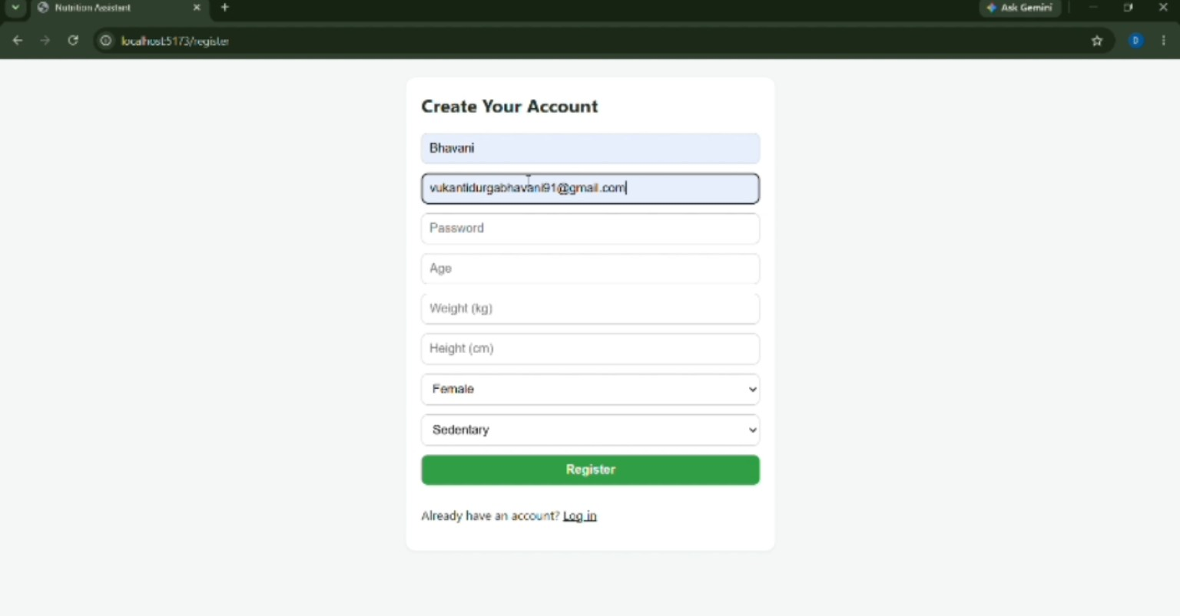
Home
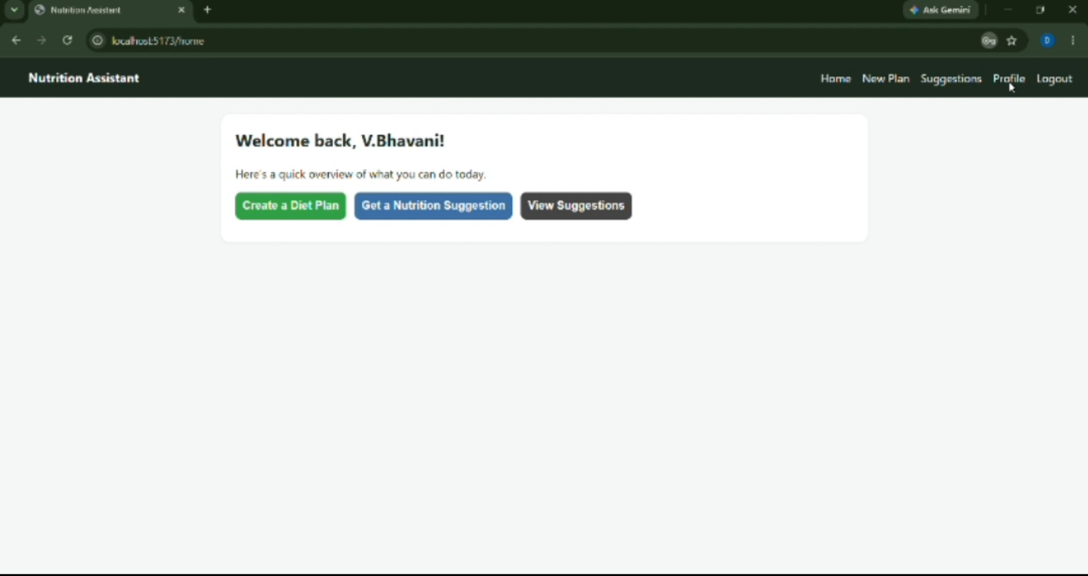
Profile
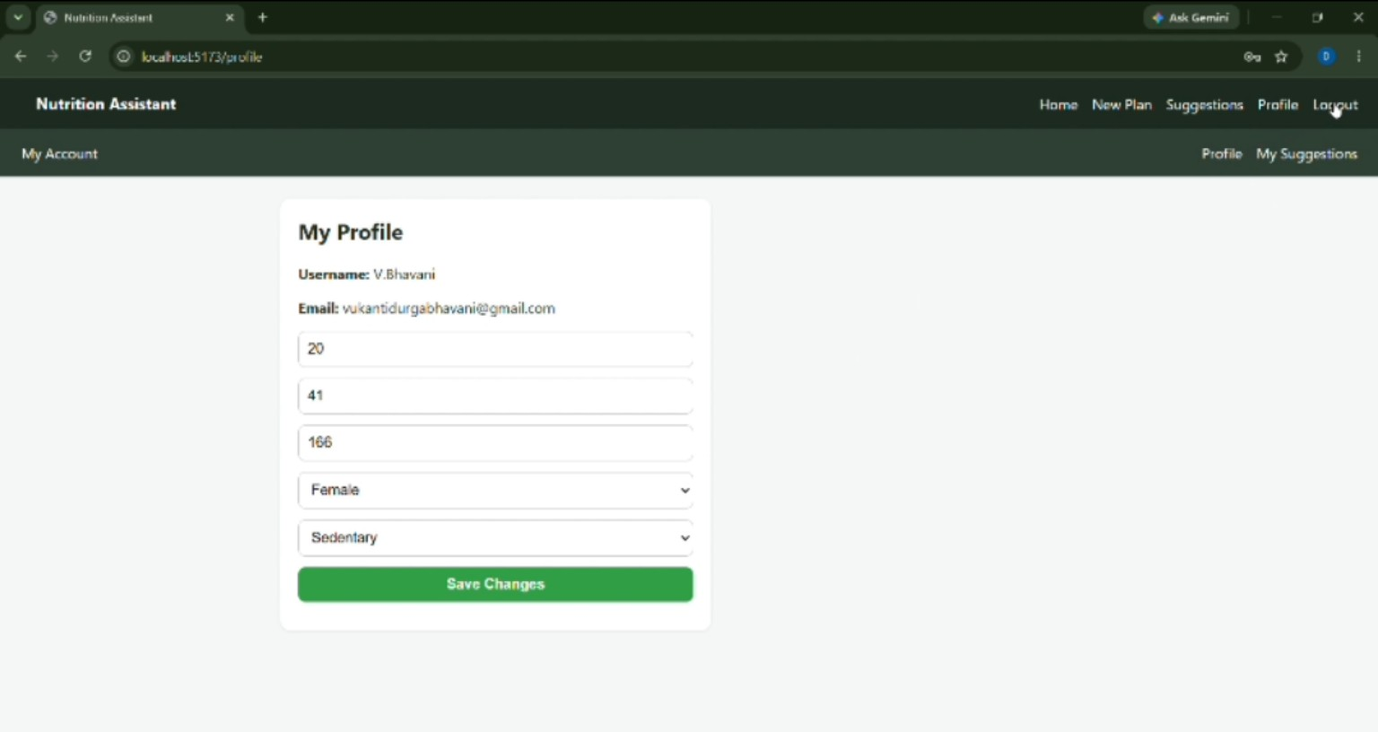

Future Scope
• AI meal planning
• Calorie tracking
• Food image recognition
• Mobile app
• Wearable integration

